Duplin County Youth Day!
Duplin County EFNEP
50th Anniversary Celebration

Duplin County Event Center
Free Event
Lunch included!

195 Fairgrounds Drive
Kenansville, NC 28349

June 22, 2019
10a-4pm
Grades K-12
♦Hands-on Nutrition Education ♦Madden Tournament
♦Zumba ♦Youth health screenings ♦Double-dutch
♦Face painting ♦Free throw competition
♦Bounce houses/inflatables ♦Food and so much more!

Sponsored by
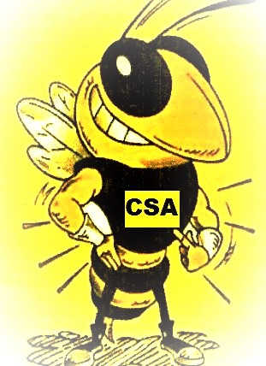
Charity School Alumni Association

♦♦♦♦♦♦♦♦♦♦♦♦♦♦♦♦♦♦♦♦♦♦♦♦♦♦♦♦♦♦♦

Contact: Nicole Swinson Duplin County 4H-EFNEP Nutrition Educator at Nswinso@ncsu.edu ♦ 910.296.2143
Tickets also available @ Eventbrite
https://www.eventbrite.com/e/duplin-county-youth-day-tickets-61007415823
See schedule on back

Youth Day Schedule!

10:00am | 10:30am | 11:00a | 11:30a | 12:00p |  | 12:30p | 1:00p | 1:30p | 2:00p | 2:30p | 3:00p | 3:30p | 4:00p
Grade K-2
Madden Challenge  (K-2) | Zumba  (K-2) | Face painting  (K-2) | Lunch  (K-2) | EFNEP  (K-2) |  |  | Old Skool Games  (K-2) | Cooking Competition |  | Outside Games & Inflatables
Blender bikes  (K-2) |  | Free Throw  (K-2) |  |  |  |  | Soccer Skills
Grade 3-5
Old Skool Games  (3-5) | Soccer Skills | Zumba  (3-5) | Free Throw  (3-5) | Lunch  (3-5) |  | Madden Challenge  (3-5) | EFNEP  (3-5) |  |  | Cooking Competition |  | Outside Games  &  Inflatables
 | Blender bikes  (3-5) | Shoot  Out  (3-5) | Face painting  (3-5)
Grade 6-8
EFNEP  (6-8) |  | Blender bikes  (6-8) | Zumba  (6-8) | Free Throw  (6-8) |  | Lunch  (6-8) | Face painting  (6-8) | Outside Games & Inflatables |  |  |  | Cooking Competition
 |  | Madden Challenge  (6-8) | Shoot  Out  (6-8) |  |  |  | Soccer Skills
Grade 9-12
Free Throw  (9-12) |  | EFNEP  (9-12) |  |  | Madden Challenge  (9-12) |  | Lunch  (9-12) | Blender bikes  (9-12) | Outside Games  &  Inflatables |  |  | Cooking Competition
Zumba  (9-12) |  |  |  |  |  |  |  | Soccer Skills
Instagram Scavenger Hunt

